Functional Skills Strategy 2022-2023
Introduction
The strategy sets out what we aim to achieve, how we will track our progress and how we will help improve outcomes for students.
Functional Skills were originally identified within the Tomlinson Report as an essential aspect of core learning. Tomlinson proposed that getting the basics right was one of the main reasons for the intended 14-19 reform and that the achievement of functional Mathematics, Literacy and communication and ICT would provide young people with a foundation for the rest of their lives.
The Leitch review of Skills: “Prosperity for all in the economy-world class skills” published in 2006 found that almost one half of adults (17million) have difficulty with numbers and one seventh (5million) are not functionally literate. The review concluded that to achieve world class skills will require 95% of adults to have functional literacy and numeracy (basic skills) up from 85% literacy and 79% numeracy in 2005; more than trebling projected rates of improvement to achieve a total of 7.4 million adult attainments over the period. Functional Skills are described by the DCSF as… “core elements of English, Maths and ICT that provide an individual with the essential knowledge, skills and understanding that will enable them to operate confidently, effectively and independently in life and work.”
Statement of priorities
Skills of Growth-the National Skills Strategy
The Government White paper. ‘Skills for Growth’-the National Skills Strategy’, published on the 11^{th of} November 2009, marked a radical shift in some of the priorities of the current skills system.
National targets and aspirations
Academic year 2020-2021
76% of general population has functional numeracy skills, with 80% of the prison population at that level
82.9% of 19-year-olds were qualified to Level 2, relatively stable compared with the previous year.
73.0% of 19-year-olds achieved Level 2 in English and maths, the highest on record.
32.7% of 19-year-olds who had not achieved Level 2 in English and Maths at 16 had achieved both by 19, the highest on record.
Assessment | 1st Time Pass Rate | Overall
Maths Level 1 | 43% | 33%
Maths Level 2 | 39% | 34%
Reading Level 1 | 82% | 76%
Reading Level 2 | 72% | 66%
Writing Level 1 | 68% | 60%
Writing Level 2 | 69% | 61%
Maths Level 1 | 43% | 33%
The graph below shows a comparison of Functional Skills Pass Rates for the years 2020/2021 and 2021/2022.

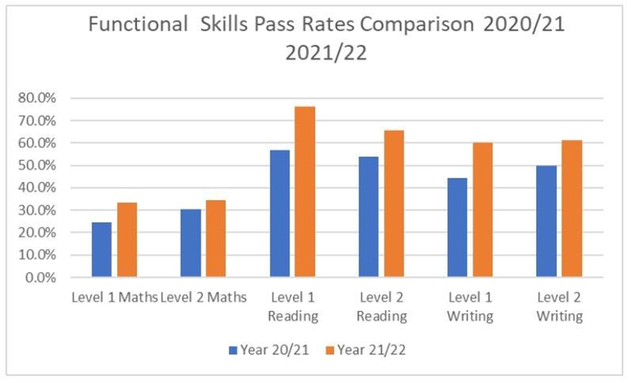
https://www.pearson.com/uk/educators/training-providers/insight-blog/2022/08/functional-skills-pass-rates-2021-22.html
[viewed 16/12/22]

ICT Pass Rates 2020/21
Assessment | First Time Pass Rate | Pass Rate
ICT Level 1 | 55.0% | 43.4%
ICT Level 2 | 53.4% | 43.2%

ICT Pass Rates 2021/22
Assessment | 1st Time Pass Rate | Overall
Level 1 | 34% | 37%
Level 2 | 58% | 55%

Functional Skills are practical skills in English, Mathematics and ICT that enable students to deal with practical problems and challenges in real life. Students are equipped with knowledge and skills which they can use when in employment or further education.
Canto Learning Functional Skills Strategy
We are fully committed to the Government initiative and Leitch targets to ensure that our students are equipped with the Functional Skills to provide the essential knowledge, skills and understanding that will enable them to operate confidently, effectively and independently in life and work. 14-19 Education and Skills Implementation Plan (DfES 2005). Currently Functional Skills qualifications are offered to students on the iCan programme via discrete courses. The aim is to successfully embed Functional Skills across the entire programme in response to OFSTED advice.
Our mission remains to provide supportive training of the highest quality to individuals with learning difficulties and disabilities to improve their quality of life through a programme of activity aimed at improving their skills for life, increasing social integration, and supporting their personal development and career Progression.
Aims of the Strategy
The primary aim of the Functional Skills Strategy is to contribute to national and local priorities identified by the Government and enable our students to meet their potential, become economically active and develop skills relevant to both work and life.
In pursuit of this aim we will:
● Continue a Whole service approach to English, Maths and ICT, maintaining staff engagement with the Skills, agenda through FS staff development meetings, peer observation, learning walks, sharing of resources, approaches which can be used to teach FS. walk ins, peer observation
● Work collaboratively with other partners including the Local Authority, colleges, and employers to raise participation and engagement of individuals with learning difficulties and disabilities in education.
● Improve standards in teaching and learning by ensuring that staff are fully qualified and undertake continuous review and professional updating, especially in relation to their own English, Maths and ICT qualifications and skills.
● Raise achievements in English, Maths and ICT and increase students’ potential to achieve qualifications by conducting internally set and mock assessments termly.
● Have a responsive, flexible and professional workforce to deliver English, Maths and ICT in a vocational context.
●Use best practice to inform and drive curriculum challenge.
● Increase and improve use of interactive and online teaching, learning and assessment resources.
●Keep staff informed of current national developments in respect of English, Maths, and ICT by assessing external training as appropriate. The FS lead must attend regular trainings, for example on changes to the specifications, new approaches, the national curriculum expectations and then feedback to the FS tutors.
● Up-skill and re-train staff especially in relation to their own English, Maths and ICT qualifications and skills to raise the quality of teaching, learning, and training.
●Ensure that Functional Skills delivery is flexible in terms of location, time, method of delivery and vocational context so that the needs of students are met as much as possible.
● Continue to reinforce English, Maths, and ICT in vocational programmes, within the Service, community and workplace.

Student journey from initial enquiry to initial assessment.
Most of the students on the iCan programme will write an initial assessment set by the examination board NCFE in English, Maths, and ICT when they first join the college. The assessments are marked by the respective FS subject tutors and a level of Entry Level 1-3 and Level 1-2 awarded based on the results attained. Once a level has been awarded, individual students will be offered activities and learning outcomes which meet the individual needs of their levels.
Students will have an opportunity for referral, advice, and guidance regarding opportunities to improve their qualifications. The subject of Functional Skills will be raised by tutors at the outset of courses where all tutors raise awareness of provision available. Should literacy or numeracy issues present themselves during a course, tutors will confidentially and appropriately remind students of course availability. Students and tutors have an opportunity to record requests for further information in their ILPs. Students on the Turing programme do not involve a disproportionate level of time or out of context activities devoted to functional skills assessments or teaching but will use naturally occurring opportunities to support and encourage improvement and continuously raise awareness of the role of strong functional skills can play in all areas of learning including leisure. The college offers students on the Turing program, Functional Skills Workshop if they wish to choose.
Vocational Learning
In addition to the discrete Functional Skills lessons, vocational tutors identify naturally occurring opportunities within their curriculum to consolidate and reinforce skill development.
Where applicable, discrete provision can be provided in a contextualised format, however, due to learner numbers and course viability students will be encouraged to join mainstream Functional skills classes alongside their vocational programmes where necessary.
Students requiring a certain level of Functional Skills to complete their vocational programmes may be required to improve skills via an appropriate Functional Skills such as phonic reading skills to help in reading before their enrolment is accepted. Full support to identify a suitable learning opportunity will be provided.
Other Qualification Based Learning
Some courses require a certain standard of Functional Skills pre-enrolment to support learner success, this process is detailed under Information Advice and Guidance below. Students will have an opportunity to demonstrate skills and knowledge in the absence of formal qualifications via suitable screening tool. If their functional skills are not yet at the appropriate level for the qualification they wish to join, for example students who are illiterate may need to do Pre-Entry tasks in which they learn the basic phonics in English so they can read.
Approaches to teaching Functional Skills
It is expected that every available opportunity to embed and enforce Maths, English and ICT will be maximised by the whole delivery team in the following ways.
Maths
Maximising opportunities for Mathematical use in all learning activities
Extending opportunities for the use of data in all coursework
Using presentations techniques such as graphs, charts etc., wherever possible.
English
Developing the conventions of discussion in the classroom
Ensuring the appropriate use of verbal and written language in formal and informal situations
Modelling good practice in the preparation of teaching materials and feedback
Marking students’ assignments for content, spellings, punctuation, and grammar.
ICT
Using digital recordings and images to evidence progress
Signposting to online learning resources
(The list is not exhaustive)

Quality Assurance systems and Procedures:
Assessments and tests schedules
Students’ progress is reviewed on a regular basis through a one-to-one tutorial and ongoing assessments of students’ attainments in sessions. Tutors record and track students’ progress in their tracking sheets. Students who achieve the required standard on their appropriate level of Functional Skills practice assessments are registered to enter and controlled assessments for Entry Level 1-3 and externally set assessments for Levels 1-2.
Maths
Entry Level 1-3
Canto Learning is currently using NCFE as the examinations body. All the assessments for Entry levels 1-3 are set externally and marked internally by the tutors and are written on a demand. Mathematics assessments are based on the requirements of the reformed specification which was implemented from 2019. The assessments are written in two parts which are non-calculator and the calculator. The mark schemes are provided by NCFE, the examination board. The completed assessments are marked by the tutors, moderated by the examinations officer, and verified by the NCFE before certificates are sent to Canto Learning. The Maths Entry Level 1-3 controlled assessments must be invigilated by a staff who does not teach Maths unless there is a shortage of staffing.
Level 1
The Maths assessments are externally set and externally marked by NCFE, the examinations board. The candidates will be registered on demand after the tutors are satisfied that they are ready to write the assessments. Assessments are sent to canto Learning a few days before, kept in a secure place (locked safe) and taken out a few minutes before the candidates write them. Additionally, the assessments are opened in front of the candidates as proof that they were still sealed. Selected staff will invigilate the assessments, sign all the paperwork and post to NCFE within 24 hours using recorded delivery.

English
Entry Level 1-3
Canto Learning offers students who are ready Entry level 1-3 controlled assessments. All the assessments for English Entry levels 1-3 are set externally and marked internally by the tutors and are written on a demand. The English assessments are based on the requirements of the reformed specification which was implemented from 2019. The assessments are written in three parts which are a) Writing, b) Reading, c) Speaking, Listening and Communication. The three assessments are written on separate days and times depending on demand and under examinations conditions. The English assessments must be invigilated by a staff who does not teach English unless there is a shortage of staffing. The mark schemes are provided by NCFE, the examination board. The completed assessments are marked by the appointed tutors, moderated by the examinations officer at Canto Learning and verified by the NCFE EQA officials who come to inspect all the related paperwork before certificates are sent to Canto Learning.
Level 1
The Level 1 English is comprised of three components namely a) Reading, b) Writing and c) Speaking, Listening and Communication. The three components are written separately on different days and times within Canto Learning building. The assessments’ three components are both externally set and externally marked. Appointed tutors will invigilate the assessments. There will be a minimum of two invigilators who do not teach English. Assessments papers, which are delivered a few days before the assessment day, must be kept in a secure place, and must be opened in the presence of the candidates and invigilators in the assessment room. All the assessments are to be written in examinations conditions. As soon as the candidates finish the assessments, invigilators will sign the necessary paperwork and all the assessments put into provided envelopes and posted to NCFE by recorded delivery within 24 hours. Assessments for Speaking, Listening and Communication must be recorded and all the recordings to accompany the assessments. The candidates must be informed that their Speaking, Listening and Communication assessments will be recorded.

Information, Advice and Guidance
Through the information, advice and guidance process (IAG) we gather a range of information on each student to ensure that the student is following the most appropriate learning programme tailored to the individual needs to achieve the goals.
The initial assessment in Functional Skills is used as part of the entry process to ensure that students are placed appropriately according to their individual levels and needs to achieve.
Good Practice
Good practice is identified through observation of Teaching learning and assessment, walk ins, peer observation, learner satisfaction and Tutor course evaluation.
Examples of good practice, including resources, are freely discussed amongst the faculty and are available to all.
Good practice is disseminated across Canto Learning through team meetings, informal tutor discussions and on-going self- assessment discussions.

Performance management
Senior Leadership Team, comprising of The Head of Centre and the two deputies will ensure the consistency and coherence of delivery of Functional Skills across the service is maintained. Performance data in relation to retention achievement and success will be raised directly with the tutor team to ensure early identification and implementation of improvement measures which will support the upward trend of performance in this area.
Key Future Actions
If there are issues which arise because of meeting between the Senior Leadership Team and the individual tutor, they will be discussed with the concerned tutor in a professional context. Minutes of the meeting and discussion of the issues will be recorded and read to the tutor for agreement and passed as a correct record. The tutor will be asked to sign and an action to correct the issue planned and put into place for future use. The Senior Leadership Team will file the action plan and the tutor will be given his action plan for reference in future. The senior leadership team together with the Functional Skills lead will continue to monitor the progress regarding the agreement in the meeting. At the end of a specified period, the Senior Leadership Team will meet with the tutor to check the progress which has been made following the setting of the action plan. If the tutor has not met the requirements of the action plan, he/she will give reasons and then alternative actions added to the action plan including support.

